Helping Others

Make Positive Change

Capella’s ‘Viewpoint Coaching’

an Activity Toolkit



# Jos Razzell

## Contents 2

**Introduction** 3

### **1. Talk about it — why use solutions-focussed coaching conversations?** 7

Making a ‘big picture’ agreement 10

Wheel of everything 11

Agreeing a ‘now’ focus 12

Finding out more and checking options 12

Agreeing actions and getting accountability 13

Giving and receiving feedback 14

Coaching checklist 14

### **2. Map it — why use mapping techniques?** 15

### Mapping ‘old story/new story’ 17

### Mapping what’s around me – my ‘environmental system’ 18

### Mapping ‘me, my strengths and my inner blockers’ 19

### **3. Try it out — why use ‘viewpoint’ spaces?** 21

Discovering solutions — future projection 22

Empty chair — speaking from points of view 23

Practicing difficult situations — modelling new behaviours 24

Offering ‘take away’ strengths 25

### **4. Do it — making real life changes** 26

Making positive lifestyle changes 26

Managing time 28

Developing boundaries — choices and agreements 30

Understanding and shifting cognitive distortions 31

Stepping out of the drama triangle 33

Befriending our defences 35

Last word — breakthrough psychology: three key concepts 37

# Introduction

This guide is for people doing support work in any sector or context. Capella ‘Viewpoint Coaching’ uses a unique combination of coaching, mapping and action methods to unlock imaginative solutions and ensure real ownership and accountability in the people you support.

There are four stages to Viewpoint Coaching:

* Talk about it (through coaching conversations)
* Map it (using concretisation)
* Try it out (using ‘viewpoint’ space)
* Do it (by making real life changes)

The very simplest use of this is when professionals are sharing their expertise (for example giving health advice or other guidance conversations). Time is short and there’s a lot to discuss – so finding ways to get ownership and commitment to change from the person you’re working with is a particular challenge. By framing the conversation with coaching-style agreements and accountable actions, using small objects to map key points in order to make choices more tangible, and concluding with a simple one minute ‘imagine you’ve achieved this change and tell me what you did’ to convert good ideas into a new self-story, you can vastly improve your chances of someone walking out of the door and putting your great ideas into action.

Other support work, especially that targeting people who are really struggling to function effectively in a particular aspect of life or work, takes more time, and the activities and tools in this guide can be used for longer, more coaching-based interventions. So what are the key differences between the different stages of the ‘coaching plus’ approach?

Coaching and mentoring usually involves sitting, talking, reflecting and planning together. This kind of discussion-based coaching accesses the frontal cortex of the brain – our analytical minds – and is very effective for cognitive problem solving. However to shift deeper ‘inside’ blocks – long-held emotional assumptions and their associated behaviours – sometimes you need more than talking to unlock solutions people are prepared to try out in their lives.

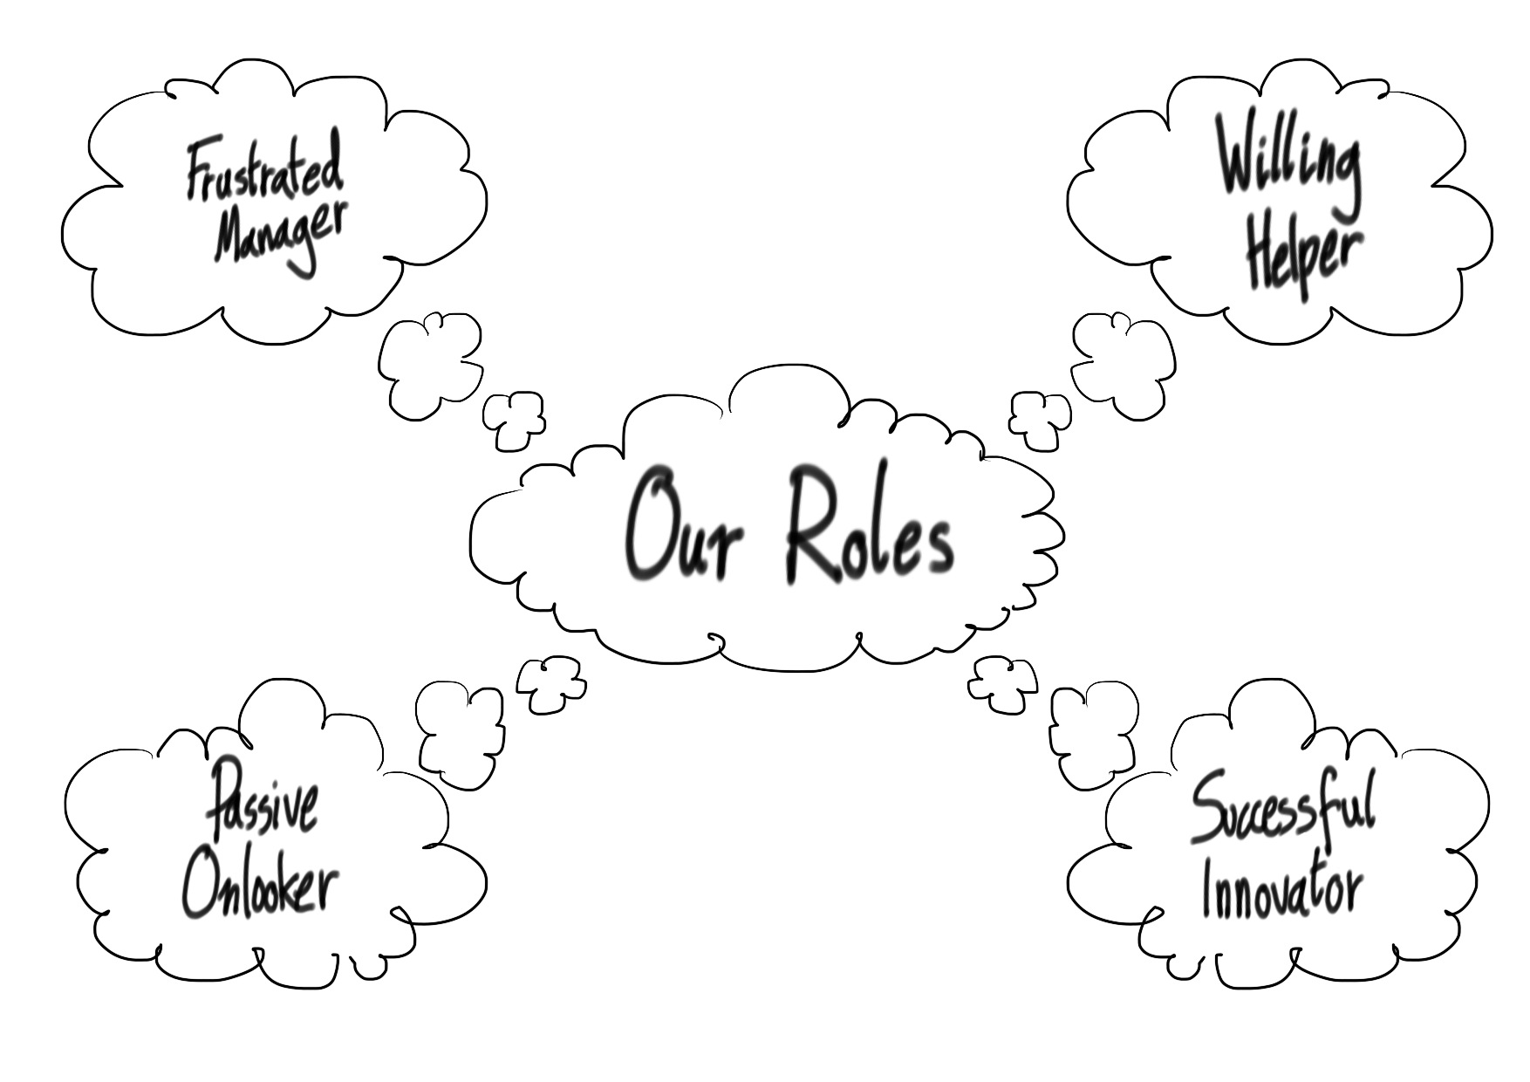

Mapping involves using labelled pieces of paper or objects to create a visual / physical representation of key aspects of any given situation. The great thing about mapping is that people feel more in control of the change process – the physical placement and movement of paper or things activates a different part of the brain, meaning change exploration is experienced at a deeper and more tangible level.

‘Viewpoint’ spaces provide the next stage on the journey, bringing what’s been mapped to life by using story-telling techniques. The ‘viewpoint space’ is simply a separate space in the room you can move to from the more static ‘coaching’ chairs – it can be around the same table, or immediately adjacent, and contains little more than another couple of chairs.

This space is used to help the people you support access their imaginations through use of story-telling techniques, re-telling their inner stories, imagining themselves into new identities or points of view, practising new approaches and unlocking unconscious solutions.

Entering the ‘viewpoint space’, people can tap directly into unconscious ‘old story/new story’ beliefs, accessing their intuition and unconscious problem solving to shift more embedded inner ‘blockers’.

### Key roles

As a **coach** you listen, observe, ask the right questions and give useful feedback to enable learning about self and situation to take place.

As a **noticer** and **mapper**, you model and assist with developing objectivity and mindful calm instead of getting caught up in the drama of events, and a ‘this happened then this happened’ kind of conversation. You are alert to noticing and then mapping patterns and key learning points.

As a **viewpoint-space** **storyteller**, you offer people a new way of discovering and sharing possibilities and learn from significant events. These aren’t fictional stories about other characters but stories about someone’s life, whether it’s what’s already happened or imagining what they’d like to happen in future.

Using storytelling you can help the people you support to bring their inner and outer world system to life in the room, and have space to rehearse, experiment, explore and directly dialogue with key parts of themselves, notional others and even abstract ideas such as ‘stress’, ‘happiness’ or ‘future’.

### Believing in others

Evidence shows that other people’s unspoken beliefs and assumptions about what you are capable of makes a direct impact on your progress and achievement. This of course works in reverse so by showing you believe in the potential of those around you, you are becoming a powerful force for positive change.

At every stage we work to show people their full potential and believe in the very best versions of themselves and their work.

### Therapeutic coaching

There’s a lot of debate about the boundary between coaching and counselling/therapy. Our assumption here is that it is possible to create therapeutic and healing spaces using coaching, without being a counsellor or therapist.

Counsellors and therapists are fully equipped to meet and support deeply challenging emotional disruption and distress: mental health issues, complex trauma, and forensic work is all within their remit.

Coaches, on the other hand, can work to support mental wellbeing if this is a blocker to making practical life changes, which is their primary focus. If the blockers are about someone’s inner state, you may well meet emotional release at points – this is part of healthy emotional processes as people re-integrate parts of themselves they didn’t have the resources to take care of previously. By keeping the ‘big picture’ focus on making practical changes and actions, a distinction is kept from counselling or therapy work.

The following emotional intelligence precepts can be a helpful starting point for practitioners:

1. **We are all responsible for our own actions and feelings.**  We naturally respond emotionally to what others do, but we remain responsible for our own feelings at all times – that way, we don’t get used to feeling like a victim.
2. **Asking for what you want is very helpful as long as other people have a real choice about how to respond** rather than feeling pushed (if people don’t know, they can’t respond). It’s helpful to understand the value of clear requests and agreements as part of healthy communication.
3. **Self-care and self-value is a great foundation for all healthy relationships** – if you value yourself and take your own needs seriously you’re in a much better position to do the same for others.
4. **Learning to notice / take care of your more vulnerable feelings and stay open generally makes you a stronger person**.
5. **Knowing your own strengths and values** really helps youstay steady when things get tough.

These precepts are as useful for us as practitioners to live by as they are for us to share with people we support. Live it for yourself, then modelling and explaining to others will be both authentic and easier to do.

Live it then teach it:we strongly recommend you try these activities out on yourselves/each other before using them with people you support, as the ‘live it then teach it’ approach helps you understand and use the process much more effectively.

# 1. Talk about it – why use solutions-focussed coaching conversations?

## The coaching relationship

Coaching and mentoring are both approaches which draw out skills and help give a sense of choice, purpose and direction. Gaining confidence in working out your own solutions and experiment with different approaches can be transformative.  A good coaching relationship makes people feel special, fully seen and heard, and creates a place where you know that what you think and feel are important.  This in itself can be a transformative experience.

## Coaching and mentoring continuum

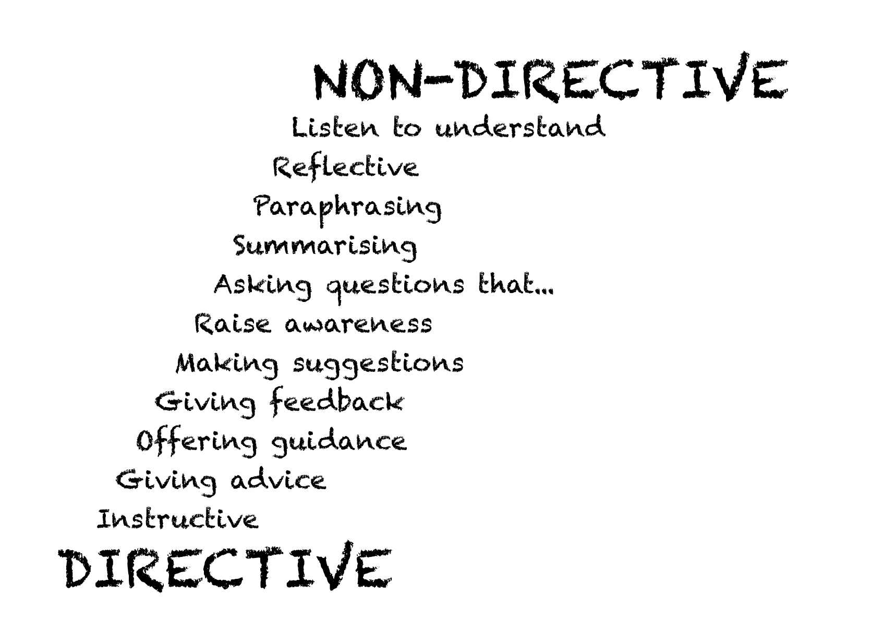Coaching is a non-directive activity, which uses skilled listening and reflective questioning to help the people work out solutions and effective strategies for themselves.  Coaches will offer feedback and make suggestions, but they don’t need to know more than their client does about the focus of the conversation to be of use to them.

Mentoring is a more directive relationship.   A mentor will often have more experience than their mentee – whether this is industrial/professional experience and skills or life experience.  Mentors are more likely to use their know-how to make constructive suggestions and give advice.

Group facilitation work often requires a delicate and sometimes frequently shifting balance between these two roles. However, change is usually more likely if the person works out, or at least articulates, ways forward for themselves.  Knowing the difference between coaching and mentoring and explaining this to the groups you work with will make it easier to select the best approach in each situation.

## Staying solutions focussed — ‘yes I can…’

When you work in a support or behaviour change role, you will often find yourself being reactively pulled into problem solving mode. You can turn this on its head by starting with looking at what’s going well, and how this can be extended or replicated, then move your way from there to addressing the challenge or difficulty. In this way we not only grow both optimism and creativity, but surprise the person we’re supporting out of their ‘known zone’ of ‘I bring problems wherever I go’ – an experience which many long-term service users have experienced, from school onwards. This is the basic starting point for positive psychology, which offers ways to develop wellbeing and resilience.

## The GROW model

The GROW model is a way of structuring a full coaching session (rather than a more informal support conversation) to get full understanding of a situation and finish having agreed effective ways forward.

**GROW** stands for:

* **Goal?** What’s the focus of the session? You can ask how they will know if the time has been well spent, what needs to have happened?
* **Reality?** This is the stage that often gets skipped or not given enough time. Be like a sniffer dog - look around the coachee, ask about their situation and others involved – then dig downwards a little, finding out what’s really happening inside, what thoughts and feelings are involved.
* **Options?** Once you’ve checked the reality, a fuller range of options will become more apparent. Wherever possible support the coachee to identify the options and choose the best ones.
* **Way forward?** Agree an action plan. Make sure this is recorded, and that targets are SMART (specific, measurable, achievable, realistic, time-referenced).

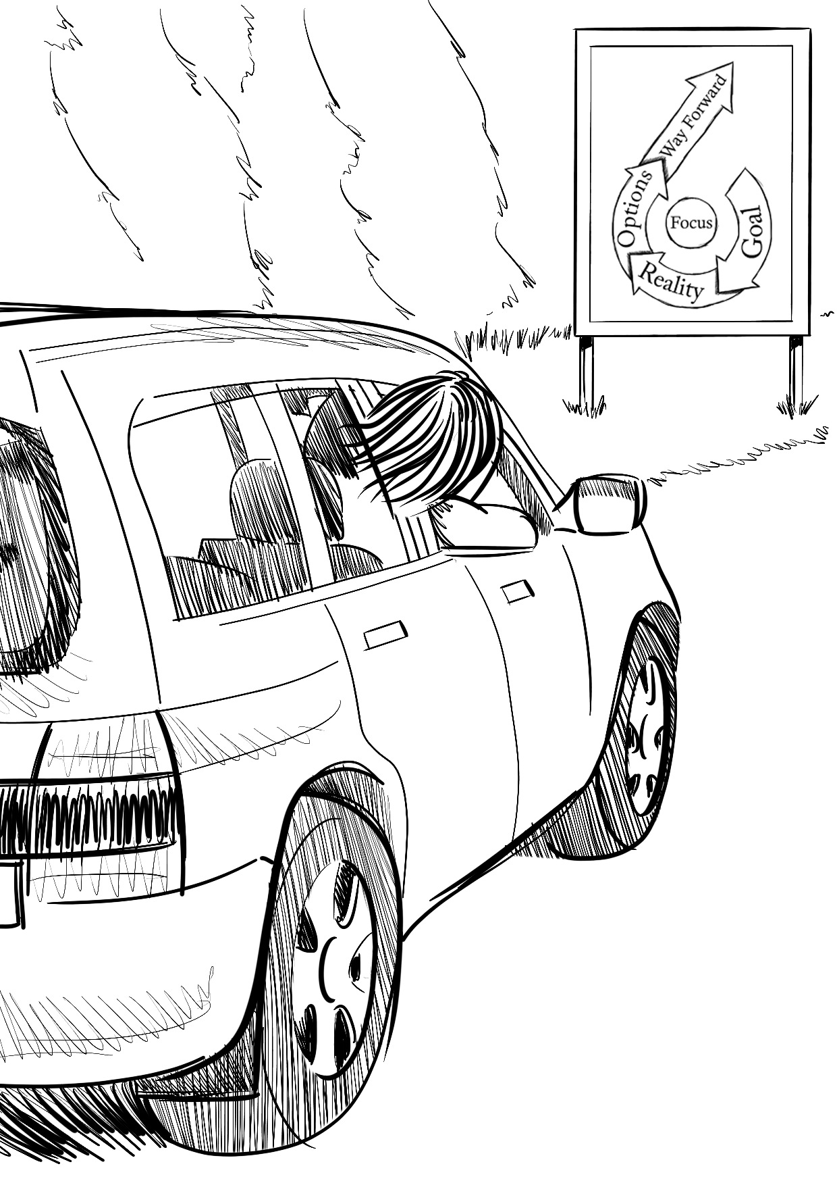If you struggle to remember acronyms, another way to think of the GROW model is as the story of a journey.

At the beginning of the journey you need to find out where you are going (your **goal**).

Then as you set off you become aware of the landscape, the weather, the other people you’re travelling with, how well the car is performing (the **reality** checking stage).

At a certain point you’ll have to choose which road to take to get you where you want to go (the **options**).

Finally you arrive at your destination ready to open the door and get out of the car (the **way** **forward**).

Asking questions

Understanding what questions to ask and when are essential aspects of coaching and mentoring.  Following your own curiosity about the other person and their circumstances is a good place to start when forming questions. Open questions are more useful than closed questions. Here are examples of both:

1. Closed question: How much exercise do you need each week?
2. Open question: What would "being fit" look like for you?

The closed question might be making an assumption that exercise is the way in which the other person would like to improve their fitness. Closed questions often point to solutions imagined by the person asking the question rather than those discovered by the person answering.

Open questions allow space and time to think, reflect and form answers. Very often the best are short questions and might provoke silence. Sitting in silence might feel uncomfortable for both of you and requires patience and often courage. The end result, however, can be powerful.

The following question types will all elicit different kinds of information:

1. **Summarising**: “So what you’re saying is….?”
2. **Unpacking / going deeper**: “Can you tell me more about…?”
3. **Temperature checking**: “How comfortable do you feel with…?”
4. **Forward action prompt**: “So how can you make that happen…?”
5. **Checking motivation**: “So why did you….?”
6. **Developing self-awareness:** “What do you notice about yourself in that situation?”
7. **Learning from the past**: “What might you do differently if that happened again?”
8. Making suggestions / offering feedback:

* “I wonder if….”
* “I might be wrong about this, but I’m guessing that….”
* “Maybe… what do you think?”

## Levels of listening

Being a ‘good listener’ means different things depending on the situation you’re in:  keeping an ear open for your children at home while you listen to the radio needs ‘cosmetic’ listening skills, while chatting socially involves conversational listening skills – turn taking, interrupting etc.  When someone is actively listening they concentrate to take in information – you can tell this is happening by the level of eye contact and their attentive body language.

Deep listening requires you to create an empathetic connection, entering an energetic feeling state which allows you to listen to someone on several levels at once – to what they are apparently telling you as well as the often unspoken truth behind their words.  This kind of listening takes energy, and can’t be sustained for long periods without resourcing yourself effectively.  It can be a very useful skill to have as a facilitator or coach; in fact, it is probably the most important one.

## Making a ‘big picture’ agreement

It’s useful to have an overview of what differences the person you are supporting would like to see happen in the immediate future – say over the next two-three months. This becomes the focus for your ‘big picture’ agreement – some longer-term objectives that you’ll keep in mind as you move between conversations over time — for example, “I want a more healthy lifestyle”, or “I want to feel less stressed and more in control of my life”.

One way of finding out which areas of life or work someone needs help with is the Wheel of Everything activity (see the photocopiable handout overleaf). You can either use a blank copy or suggest your own categories to suit the person you are working with and what they are likely to want to discuss. This works well because people can show you information without having to directly say it, which a lot of people find much easier to do.

## The Wheel of Everything

What areas of life are important to you? Choose some from here, and/or add some of your own… and label each segment of the wheel with one key word.

|  |  |  |
| --- | --- | --- |
| HOME | WORK | STUDIES |
| RELATIONSHIP | RELAXATION | HAPPINESS |
| SELF-CONFIDENCE | ACTIVITIES | FRIENDS |
| BODY | HEALTH | FAMILY |

Now mark how things are going for you in each of these areas.

If things are going well or feel easy, mark near the centre of the circle in that segment.

If things are going badly or feel more difficult, mark near the edge of the circle in that segment. Or anywhere in-between!

Then discuss what you see when you finish.

## Agreeing a ‘now’ focus

### At the beginning of each conversation or session, it’s very helpful to get a clear agreement with the person you’re supporting on what they’d like to talk about, and what they’d like to have achieved or got sorted by the end (for example some ideas to try, a clear plan, feeling better about a situation).

### This is just as relevant for a ten minute chat as an hour long coaching session. You can find this out with these two questions:

1. What would you like to talk about today?

### How will you know if our time together has been helpful?

## Finding out more and checking options

Getting to the bottom of a situation can take some good listening and careful questions and checking. You and the person you’re supporting might think you’ve fully understood what’s going on, but the chances are a bit of wider or deeper questioning will give extra information which helps the chances of getting really good ideas for next steps.

**Top tips for this kind of conversation include:**

* **Asking for someone’s own ideas before making any suggestions or giving feedback** — if the thinking comes from them they’re much more likely to really understand it, own it and then act on it. It can take real effort to hold back giving your great suggestion or insight, but it pays to let them lead most of the time, unless they are clearly out of ideas or don’t know something important and useful.
* **Watch out for chances to help people ‘self-notice’** how they are functioning as well as what has happened to them and what they’ve done.
* **If you spot an attitude pattern, make a mental note**, as it can be useful to feed this back at the right moment, including then and there if it feels right.
* Help give more feelings of control and choice by using objects (pieces of paper, pens, keys etc) to represent people, feelings etc. Then the person you’re supporting can move them around, push them aside, make them central etc

## Agreeing actions and getting accountability

Before you finish the conversation, make sure you are both clear about what the person you are supporting is going to do next. The big challenge here is just that – challenge. Lots of us like a ‘get out’ clause — “If I’ve got time”, “I’ll probably do it”.

The fact that you’ve had to discuss it suggests you’re trying something different or new, and most of us have some reluctance in that area, alongside a wish for change.

Knowing that you have made a firm commitment to someone else and that they will ask you about it later can make all the difference to whether you follow through or not.

**Top tips for planning and making sure they mean it include:**

* **Write the actions down** – in their words not yours (if they write them down, even better!)
* **Spend time pinning the actions down with lots more questions.** Exactly what will they do, when, how often, with who – then check if this is realistic, and if not adjust. Getting really clear like this massively increases the chances of it happening.
* **Ask how committed they are to following through on these actions on a scale of 1-10**. If they give a low number, find out why, and work this through until it’s a higher one.
* **Sign off the agreement with a handshake and eye contact.** A bit cheesy, but it makes it much more real as a transaction.
* Let them know you’re interested and fully on board by saying you’ll follow up, and if possible, give them a chance to let you know how they’ve got on.

**Before you finish — two quick ways to complete a conversation:**

* **Check back to the agreement you made at the start.** Have you done what the person you’re supported wanted to do (ie made a plan, they’re feeling happier or whatever it was)?
* **Have you asked for feedback?** This matters. It shows you care what they think, you learn what works and how to get better at supporting people, plus you’re modelling the useful skill of asking for and learning from feedback.

## Giving feedback

Giving and receiving feedback can be challenging for many people, but is a crucial skill for effective self-development to take place. Learning to request, offer and accept constructive feedback is a key lever for change and development. Coaching approaches encourage us to challenge as well as praise the person you’re supporting, so they are stretched by your high expectations. Whether positive or developmental, the best feedback is always specific, genuine and descriptive.

|  |  |
| --- | --- |
| **Coaching conversation checklist. Have you:** | *Check* |
| 1. Made a ‘big picture’ agreement and/or reviewed this? |  |
| 1. Made a ‘now’ agreement about the focus and outputs from the conversation, and come back to this at the end? |  |
| 1. Spent enough time asking questions to fully get to the bottom of things before checking out options for the future? |  |
| 1. Helped the person you’re supporting reflect and notice about themselves, not just about what’s happened, and given helpful feedback on what you notice? |  |
| 1. Agreed really clear, realistic actions and checked commitment to doing these? |  |
| 1. Asked for feedback on how you’ve supported them? |  |
| 1. Listening carefully and created good trust and rapport? |  |
| 1. Made sure that the person you are supporting has done most of the talking, not you? |  |

# 2. Map it — why use mapping techniques?

## Looking at what’s really going on

When we support people the most obvious starting point for conversations is to talk about what’s happened or happening in their lives. This is of course important.

However, to make significant change, you need to get good at looking for the ‘story underneath the story’ – what’s really going on in the person you’re talking to, and what has probably been going on for some time, often as a repeating and very familiar pattern or way of being.

Mapping gives you a great frame for this kind of noticing, as well as some activities to help bring awareness and positive choice to the person you’re supporting. You can make a visual/physical map of key aspects of self and situation using post-it notes, pieces of paper and/or objects placed on a table or on the floor.

## What can be mapped? A triple focus

### At Capella we use mapping to explore and re-shape three key aspects which underpin an issue or opportunity:

### People’s ‘old story/new story’ beliefs and assumptions

### People’s environmental ‘systems’

### People’s inner and outer role states

### Stories

Once you’ve been able to see how someone’s ‘old story’ is turning up in their lives again and again, you can put this in their personal ‘map’, then work together to map a ‘new story’. This is about noticing patterns of inhibiting beliefs and world views, then replacing them with others which empower and allow for new ways of going forward.

### Systems — what’s around them?

It’s important to understand the influences, networks and structures which shape someone’s world if you want to help them change. Mapping what parts of their outer world is causing difficulty helps gain clarity and is key to moving things forward.

### Roles — who’s in the driving seat?

You can help the people you support to identify and then map both strengths and gaps in their approaches and skills — looking at roles or aspects of self they need to use to do well in the world, and roles or aspects of self that are holding them back.

### 

### Creative problem solving

When we access a state of deep connection with ourselves, others and the world around us, we feel more peaceful, alert, purposeful and alive. Problem solving becomes easier, solutions present themselves intuitively and collaboration flows. By dropping your brainwaves from a beta to an alpha state, you can feel simultaneously more relaxed and more alert and perceptive. In this way remarkable things can be achieved.

By working with physical objects you can move around, you are helping the people you support to access this state of natural connection and insight so they can make deep and lasting change.

## Mapping using objects (concretisation) is storytelling

In its simplest form, concretisation – the use of objects to represent things or ideas – is storytelling. You use nothing but the imagination when you say, ‘this bit of paper represents my friend’. In order to understand how powerful and deeply transformative our approach is, you need to take on board how powerful our imaginations are in making all things possible.

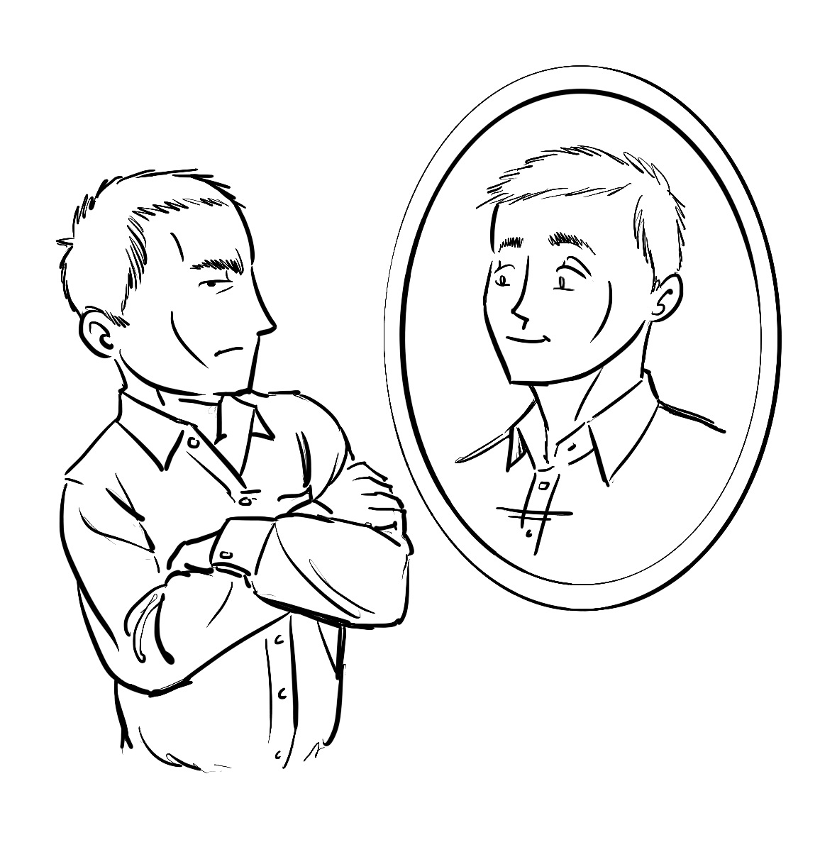If you have confidence in the power of the story-telling process when you work with people, even the most unconfident or cynical people are freed up to follow you down the path of creative possibilities.

Our ultimate goal is to support people to become their own story-tellers, re-shaping their life stories so they can move forward with a confident belief in what is possible and how they can move things forward. When solution seeking this can be done by imagining yourself into a story where you have already solved the problem — then working backwards from there becomes surprisingly easy.

## Mapping ‘old story/new story’.

There are some issues which turn up again and again in both individual and group work. These include lack of confidence, stress, being too busy and feeling overwhelmed, being able to say no to people without conflict or tension, knowing how to ask for help, stepping away from ‘blaming/being a victim/rescuing’ relationship dynamics (this is known as the drama triangle) and unhealthy lifestyles.

With any of these issues, and the many others people bring to the table, it’s useful to identify and map the ‘old story/new story’. Old stories or internal scripts are easy enough to spot – they usually start with generalising statements like, *“I always/usually…”* or*, “People tend to…. “*

These statement reflect people’s often unconscious beliefs and assumptions about themselves, the world around them and their probably future.

### How it works

Once you’ve noticed and acknowledged together an ‘old story’ you can work together to summarise it on a sheet of A4 paper in one or more simple sentences, write these down visibly and place them as a simple start to a ‘map’.

This is then balanced by ideas for a possible ‘new story’ – you can suggest how this might go to the person you’re supporting if they can’t come up with their own version:

*“How about a ‘new story’ like, ‘I can speak up when I’ve got something to say that matters to me’?”*

This kind of offer can feel both exciting (‘*Maybe there is another way?’*) and scary (‘*At least I know this way and I won’t have to make any difficult changes’*).

## Mapping what’s around me — my environmental system

We often personalise situations which are in fact largely driven by our environment or an organisational or social/peer culture. Knowing what is affecting us externally is a key step to understanding the inner shifts we can make in how we respond.

In this table-top activity we use post-it notes or scraps of paper to map external elements of a situation, then look to see if any re-alignment is possible. As an alternative to paper you can use objects for mapping – this can be more tangible and evocative/memorable – using either objects you’ve already found or anything that’s to hand in the room.

### How it works

1. Use a single colour of post-it notes to map the key elements of a situation: who is involved (both individuals and groups as relevant), what resources and support are available, what negative influences exist, plus any key challenges or opportunities.
2. Check how these various elements should be placed in relation to each other (what’s central, what’s peripheral, where the key connections are).
3. Reflect together on how this ‘environmental system’ is affecting the person you’re supporting, and whether any issues which feel personal to them are actually because of what’s around them and the system that they’re part of.

## Mapping ‘me, my strengths and my inner blockers’ (role states)

When we pay attention to what’s happening both around us and inside ourselves we notice how what we call our personality is actually a composite of many different ‘aspects of self’ or role states, each with their own way of approaching the world.

When these roles work together constructively life is easier and choices and actions can become more effective.  When there is inner conflict between these internal roles, or over-developed ‘negative’ roles are in the driving seat, we are more likely to have a hard time.

Most of the time we don’t notice which part of us is in the driving seat, or make fully conscious choices about which role to draw on when responding to situations.

We also often don’t believe that a positive inner state can belong to us – even when we’ve experienced it in the past, at moments when life feels more negative, it can be hard to believe that previous strengths still belong to us and are available for use.

Developing a deep and ‘experienced’ understanding that positive role states can exist and belong to us even when we can’t easily access them or experience them spontaneously is one of the keys to healthy growth and positive change.

It’s important to remember that even seemingly negative inner roles have been developed for a good reason in response to past situations, so we need to be respectful and considerate of all of them.

Mapping these roles or aspects of self can be powerful work, so tread lightly at first, making sure that you focus mostly on positive inner roles if you or the person you’re working with is struggling emotionally.

## How it works

1. You can add to any existing map you’ve made (old story/new story and/or external ‘system’ factors), or you can make a new map from scratch. If you’re adding to an existing map, it helps to use a different colour of post-it note or paper to distinguish one element from another.

2. As you discuss a typical challenge or situation (the more specific the better), notice, name and then map both inner and outer role states – these are the ways we typically respond to the situation (enthusiastic follower, hard-working list-maker, self-critic, self-carer etc)

3. Ask the person you’re supporting to consider what new roles they might want to introduce in response to the situation, what existing roles are under- or over-used, and place post-it notes accordingly, then debrief key learning together.

# 3. Try it out — why use ‘viewpoint spaces’?

Viewpoint spaces are flexible and easy to use. When you invite someone to step into a viewpoint space, they are exploring a situation from the inside rather than looking at it in an abstract, analytical way. By using our imaginations we can speak ‘as’ a part of ourselves, as someone else or even an abstract concept.

This feels completely different, and creates a powerful short-cut to underlying feelings, beliefs and assumptions, as well as intuitive and unconscious solutions we hold but can’t access through the analytic brain.

As with mapping, we can explore any of the ‘big three’ in the viewpoint space – external system elements, roles or aspects of self and ‘old story/new story’.

The trick here is to establish strong protocols about ‘who/what’ is speaking. In the viewpoint space you speak as the person, aspect of idea which is being explored, rather than about it. For example, “As Jake’s frustration, I think he doesn’t always know when I’m around”. This first person voice helps create separation, which in turn helps with objectivity and choice making. It also activates the imaginative story-telling part of the brain.

At first you will need to show people how to do this, and ongoingly remind them with prompts and modelling, otherwise the magic just won’t work and they will default back to the much more familiar place of abstract analysis and discussion.

Moving physically between the reflective ‘coaching conversation’ space, or the chairs you sit in when you speak, and different chairs or other markers for an viewpoint space can help make sense of this shift, if it’s possible. If not, you can still invite people to imagine themselves into speaking from different viewpoints where new possibilities emerge, for example by imagining a time when a problem has been solved and describing what ‘happened’ to get them there.

Entering ‘viewpoint space’ allows people to negotiate internal change and move towards their ‘new story’ more easily.  By giving a voice to an internal role on their personal map, that role feels more separate from the whole self, and by using a separate ‘noticing self’, people can then start to make internal requests, offers and even negotiations between the different parts of themselves, all with the aim of creating more internal balance and positivity.

Viewpoint space allows people to re-shape their self-stories imaginatively in this way largely because it uses concretisation (representing ideas with objects in physical space). This is a powerful technique which makes it much easier to do this kind of exploration than talking about thoughts and feelings in the abstract.

## Discovering solutions — future projection

This activity is useful to either firm up someone’s sense of solutions they’ve discovered or been offered, or uncover solutions they’re holding but don’t yet know about, and/or as a very tangible way of action planning.

### How it works

1. Decide between you where your start and end points will be – choose one place in the room to represent now, another for the future.
2. Ask how far ahead in time the person you’re supporting would like to explore.
3. Invite them to ‘visit’ the future by physically walking towards it while you accompany them.
4. When you arrive at the place in the room which represents this future time, ask them some easy questions to create a ‘time change’ illusion, *(“What is the date?”  “How old are you now?”  “What’s the weather like now it’s winter?”*)  **[Note**: Insist answers are in the present tense, without conditionals: *“I might have / I would / if I*” are all to be avoided – it breaks the magic spell.]
5. Once these easy questions have been answered, you can ask “So, w*hat’s happening now?*“
6. Encourage them to describe their notional future, while you ask questions about it to get more detail.  They should be describing a future where the challenge has been overcome or the opportunity fully developed – if not, steer them in this direction.  Congratulate them as they speak, as if the good things had really happened: *“Well done!  That sounds amazing…”*
7. Ask what they did or what happened in order to be able to arrive at this positive state, breaking this down into a time sequence if necessary.
8. Conclude by asking them to give some advice to their past self, who you can recall were thinking about these issues in a conversation some time ago with you.

## Empty chair — speaking from points of view

### Background

The ‘empty chair’ technique is a powerful way to see things from more than one point of view, encouraging people to use their imagination and empathy to step into either their own or someone else’s shoes.

This activity looks similar to classic role-play but in fact rather than simply playing out a scenario, it involves interviewing in role, swapping between roles and becoming more aware of dynamic interplay in the situation.

### How it works

1. Use two empty chairs to create your ‘viewpoint space’.
2. Decide what elements from their ‘map’ the person you’re working with would like to explore further, then which chair is representing what. You can label these if that feels helpful. (You can jump straight from noticing during a coaching conversation to viewpoint space empty chair work without mapping, once you are familiar with the techniques.)

*NB — chairs can represent anything from a person’s map - an inner role or aspect of self; an external system element such as another person, group of people or abstract such as ‘the rules’ or the underlying ‘old story’ or ‘new story’.*

1. Ask the person you’re supporting which element they would like to explore first, then when they have chosen, invite them to sit in that chair.
2. Help them to speak as the element rather than about it by asking some easy questions to get them into the role, using the second person, ‘you’, and speaking about them in the third person.  For example, “*So, you’re Jake’s ‘keen worker’ role.  How long have you been around?  Can you tell me a bit about yourself?*
3. Having got them speaking comfortably from role, extend the questions to elicit an opinion, preference, request, or piece of advice for themselves, speaking in the third person: “I think Jake would be happier at work if he could delegate more.”
4. Invite them to ‘reverse roles’ – to move to the second chair and explore a different role state (for example, Jake’s ‘self-critic’, then repeat the last words spoken by them when they were sitting in the previous chair.
5. Invite a response from the new position, and continue to swap between the two chairs for as long as is useful.  You can have more than two chairs to move between, once you get used to the method.
6. Invite them to go back to their original place outside the action, where you can discuss what’s happened and what’s been said.
7. ‘De-role’ the chairs when you’ve finished – move them a bit, state: “You are not my keen worker self, you’re just a chair.” This makes sure the work is properly finished and fully put down.

## Practicing difficult situations — modelling new behaviours

You can use the same ‘viewpoint space’/empty chair technique to explore the dynamics between two or more people, for example when practising skills such as speaking up, controlling anger or similar.

Often practice is only possible once a new way has been modelled. Decide together which internal roles support the ‘new story’ the person you are supporting is moving towards.

1. Ask them to imagine they’re talking to a person they typically struggle to communicate well with. You take the role of that person, first asking for a demonstration of some of typical language/emotion that you can then use to represent the character.
2. Give a piece of paper with the new role written on it to the person you’re supporting. Say your lines, with as much characterisation as possible. At this point they’re likely to pause, and comment, “When she speaks like that I usually…”, which is a way of acknowledging the ‘old story’.
3. Invite them to respond from the new emerging role, rather than the one they usually use.
4. Watch carefully what they do and say, then if useful (which it usually is) offer to have a go yourself, and reverse roles as per the empty chair technique described above.

## Offering ‘take away’ strengths

This is a great and very simple way of finished a session. Write on bits of paper key attributes the person has drawn on during the work (‘clarity’, ‘confidence’, ‘self-care’, ‘fun’ etc).

Offer each piece of paper in turn, asking if they’d like to keep it and take it away with them. You can re-enforce the feeling of being given a special gift by saying, “You can keep it. This is yours now”.

# 4. Do it - making real life changes

## Some issues are fairly universal to specific times and places. The following activities help use the three stages of coaching conversation, mapping and viewpoint space work to address the kind of issues you are likely to meet again and again as you support people to create positive change.

## Making positive lifestyle changes

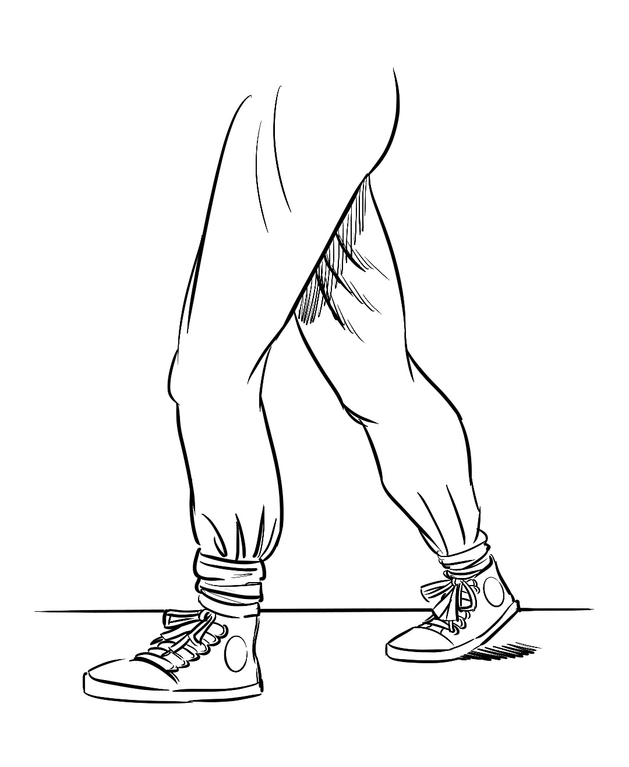

### Background

We are what we do, as much as what we think, feel and perceive. Developing a healthy lifestyle which accommodates our individual situations and states is essential to more general well-being and effectiveness, especially for those with chronic and long-term health conditions.

Most people now understand the basics of living healthily:

* **Eat well** (lots of vegetables, home-cooked rather than factory prepared food, minimum sugar and salt, healthy fats, whole grains, reduced meat consumption, social eating and time to digest).
* **Move your body** (regular gentle physical movement, stretching, exercise for good muscle tone, all building endorphins, the brain’s ‘feel-good’ chemicals)
* **Reduce stress** (don’t pile on too many tasks, make time for things you enjoy, including the everyday aspects of life, use mindfulness/meditation/noticing techniques to relax, don’t spend too much time on gadgets, get good quality social and community time)
* **Sleep well** (avoid gadgets before bed-time, get good sleep routines in place, relax and wind down in good time, get to bed early enough)
* **Take a balanced approach to change** (avoid ‘boom and bust’ attempts to make improvements such as yo-yo dieting and the setting of unrealistic expectations about new routines that are unlikely to sustain)

However, understanding in the abstract about ‘healthy’ is very different from living and experiencing it tangibly. That is the focus of this activity.

### How it works

1. Use coaching conversations and mapping to notice together what is already going really well in terms of healthy lifestyle habits and practices, and celebrate this.
2. Use ‘viewpoint space’ empty chair techniques to help the person you’re supporting ask their body, ‘What do you want, as my body? What would you really appreciate?’ You can do the same with the mind, heart and spirit if appropriate.
3. Offer them a physical object as a gift – a stone, a drawing, something they can keep. Tell them, ‘This is to make things easy for you…. When you have this, making the change should be easier.’ You can name it if you wish, for example, ‘this is your well-being,’ or ‘this is some space and time’. Ask them if they’d like to accept that gift. If they do, once they are holding it, ask them what has changed, and what they might now do differently.
4. Record intentions in an ‘action plan’ list. Make sure these are manageable and realistic. They might be as simple as, ‘notice when I’m feeling tired’.
5. Review these intentions the next time you meet. Ask what helped to follow them through? What go in the way? If there are significant obstacles, again you can use role reversal techniques to explore and address these.

## Managing time

### Background

Time management is an overused term, which has wide-reaching implications when ignored. Many people use it to describe someone who is consistently late for meetings or misses deadlines regularly, and these can be classic indicators of someone who is overwhelmed by their task list. However, others who are highly organised and never miss a beat can also have time management issues.

Consider: are you getting the most out of your time? Do you frequently feel stressed or pushed, rather than enjoying a pleasurable flow of achievable but challenging tasks? You may have a problem with saying no. Or perhaps you don’t like to hand over work to other people because (what you say to yourself) “it’s my job; I should do it” when what you really believe is “only I can – and should – do it”.

Over-committing and under-delegating are classic behaviours of impossibly busy people. What they’re often missing is that they deny others the opportunity to learn and up-skill by taking on too much work and sacrificing their leisure, relationships and sometimes their mental health to the invisible task-master who is actually themselves.

### How it works

1. Use the ‘wheel of everything’ activity to map key areas of your life, work or both. Mark you happy you are with the amount of time you give to each.
2. Create three ‘zones’ in the room – a ‘red’ zone, an ‘orange’ zone and a ‘green’ zone. If you have them, use coloured pens to mark these on paper.
3. Cut up the wheel of everything sheet into segments, and place them in the appropriate zone – in the red zone if their time allocation is a long way from their ideal, in the orange zone if they need a bit of adjustment on time allocation, and in the green zone if the amount of time they need is the same as the amount they get.
4. Visit the green zone first. Check out what strategies the person you are supporting has used to create good balance here, and why things are going so well.
5. The move to the orange zone. See if there are any easy, minor adjustments to create an optimum time balance.
6. Ask them who they see as having excellent time management skills. Use an object to represent this person and place them in the viewpoint space.
7. Finally, go to the red zone. First notice what it feels like to stand there. Then invite them to ask their ‘time management expert’ for some advice. Suggest they move to stand in the space of the expert.
8. Ask them a few easy questions as the ‘expert’. Does the expert want to offer support? Say you understand they’re great with time management and boundaries… is this true? Then ask them if they have any constructive suggestions for the person stuck in the red zone. Ask them to speak directly to that person, saying ‘you’. If they drift out of role, remind them who they are speaking as.
9. Finally, ask the person you’re supporting to step back into the red zone. Stand in the ‘expert’ space, and repeat the good advice back to them so they can hear it directly.
10. Move out of the ‘viewpoint’ into a ‘noticing space’, and discuss what has been said.
11. Deconstruct the scene, debrief and share.

## Developing boundaries — choices and agreements

### Background

Another very common development need is the ability to make clear choices, express preferences and hold boundaries with others. This skill underpins the ability to remain clear and confident in positively shaping our lives and making healthy choices. It helps build secure self-relationship, as parts of ourselves which feel under pressure or exhausted by responsibility and obligation can be better taken care of, and this in turn creates healthy and balanced relationships with others. It supports effective time management, delegation, and other very useful skills. Thanks to Susie Taylor for the warm-up activities.

### How it works

1. If the person you’re supporting isn’t yet clear about the value of making clear choices and being able to say no, you can try these warm-ups first:
   1. One person tries to persuade the other to accept an object (this can be anything – a pen, pack of tissues or similar). Their partner must consistently refuse to accept it. Try this for a few minutes then debrief about the strategies used by both people and the learning from the activity.
   2. In pairs one person instructs the other person to do whatever action they choose (give the ground-rule before this that all instructions must be respectful, considerate and safe). These should include requests for help – for example, can you get me a drink of water? Again, debrief on the experience and learning.
   3. Use the ‘Continuum line – re-framing either/or thinking’ detailed (p. 27) to explore the polarities of someone who usually says yes to requests for help, someone who usually says no, and what a clear point in the centre looks and feels like.
2. Once people are clear on the use and value of being able to say a clear ‘yes’ or ‘no’ from a place of choice rather than obligation, they can sit in a ‘choice’ chair, and practices clearly saying no to requests.
3. Try to make these the kind of real-life things they are being asked – you can speak as someone they work or live with to make the practice more real life and effective. Swap roles at points where you want to model calm, considerate but clear ways of saying no to others.
4. Debrief and share the learning from this activity.

## Understanding and shifting cognitive distortions

Background

### 

David D. Burns in his book, Feeling Good: The New Mood Therapy (Signet, 1981) helpfully outlines a list of ten common ‘cognitive distortions’, or ways to perceiving the world which are detrimental to our own wellbeing and that of those around us. Being able to spot these and share this ‘psych-ed’ know-how can be a helpful starting point for positive change. I’ve added some ‘new story’ ideas for a more positive take on these. So here they are…. Something to watch out for!

How it works

If you spot a cognitive distortion when you’re working, you can explain the concept to the person you’re supporting. It can really help depersonalise a pattern when you see it’s something that many other people have also experienced.

|  |  |  |  |
| --- | --- | --- | --- |
| OLD STORY | | NEW STORY | |
| **All or nothing thinking:** you look at things in absolute, black and white categories. |  | | More than one thing can be true at the same time, and things change – I can just notice what’s happening in the moment. | |
|  |  | |  | |
| **Overgeneralisation:** you take a negative event and assume it is a never-ending pattern. |  | | Just because this has happened now doesn’t mean it will always be the same. We can make new choices together. | |
|  |  | |  | |
| **Mental filter:** you see negatives and ignore positives. |  | | I can deliberately work to spot the good things and what I’m doing well, training myself to notice and celebrate these. | |
|  |  | |  | |
| **Discounting positives:** you insist that your positive qualities and accomplishments ‘don’t count’. |  | | Well done me for what I have done well! Although actually, I’m interested in enjoying what I do rather than proving myself. | |
|  |  | |  | |
| **Jumping to conclusions:** you either assume people are reacting negatively without any evidence or predict that bad things will happen with no evidence. |  | | I’m going to take the time to check before deciding on what’s going on and what to do about it. | |
|  |  | |  | |
| **Magnification or minimisation:** you either blow things out of proportion or shrink their importance inappropriately. |  | | It matters to me so I will take it seriously, but I know that ultimately everything will change and new options will turn up. |
|  |  | |  | |
| **Emotional reasoning:** you reason from what you feel, “I feel stupid, so I must be stupid.” Or, “I don’t feel like doing this, so I’d better not.” |  | | I can notice how I feel and care about that without losing my objectivity or sense of perspective. My judging voice may need some care too! | |
|  |  | |  | |
| **Should statements:** you criticise yourself and others with ‘shoulds’ and ‘shouldn’ts’. |  | | There is no room in my life for ‘should’ – I do things because I choose to not because I’m obliged to. I can still choose to take responsibility and extend myself to support others, but I do have a choice about this. | |
|  |  | |  | |
| **Labeling:** you identify with your shortcomings and give yourself negative labels, “I’m rubbish”, “I can’t keep up with anything” etc. |  | | Let me check if that’s true, or just an old familiar story I’ve been told and have now internalised? | |
|  |  | |  | |
| **Personalisation and blame**: you blame yourself for things that weren’t really your responsibility, or blame others while not recognising your own contribution to a problem. |  | | It isn’t helpful to me or others to judge. I can move beyond praise and blame to a steady place where I notice and make positive choices. | |

## Stepping out of the drama triangle

### Background

Learning what healthy relationships look and feel like is largely a natural, intuitive process for people as they age and mature.  However, we all come unstuck at points, and having the emotional intelligence skills to be able to respond constructively to destructive dynamics such as bullying, manipulation, peer pressure and similar can be essential for well-being and self-esteem.

This model helps to explain why people sometimes get sucked into negative dramas with each other.  Once you learn to spot the drama triangle, it is a great way to avoid both becoming stuck in a victim role or being blamed by others.

The three roles in the Drama Triangle are frequently inter-changeable – you may start in one role in relation to others but these tend to switch, sometimes quite rapidly.

The three roles are victim, persecutor and rescuer. The dynamic is only enacted when two or more people are taking on one of these roles.

### How it works

1. Put three chairs in the formation of a triangle facing each other and explain that these are representing the ‘drama triangle’, outlilning the three roles involved. Use A4 paper to label each chair with one of the three roles: victim, rescuer and persecutor.
2. Ask the person you’re supporting to sit in one of the chairs, and speak from that role. Ask them how they feel about the other roles from that position. Repeat this from each chair.
3. Now explore together how these roles can ‘flip’. Agree and then play out a ‘victim/persecutor’ dynamic, using named characters to bring this to life, for example:

* Rina, the employee (persecutor)
* Tom, the colleague (victim)
* Jan, the boss (rescuer)

1. When you have played out the conversation for a few minutes, representing each character between you, ‘shift’ each character to the chair on their right – so they change role – victim to rescuer etc. Continue playing out the scenario with the characters in their new roles.
2. This exercise shows how the Drama Triangle dynamic, once in place, tends to shift people between the three roles – persecutors become victims, rescuers become persecutors, etc. Once you are aware of the dynamic and can spot an invitation to join it from others in your life, it is much easier to avoid getting sucked into or generating negative blame-based dramas.
3. The more positive alternative to the Drama Triangle is called The Empowerment Dynamic (TED), also figured above, a triangulation of roles which can be positive and help create effective and useful change when relating to others.  You can try this out as an alternative to the Drama Triangle.

## Befriending our defences

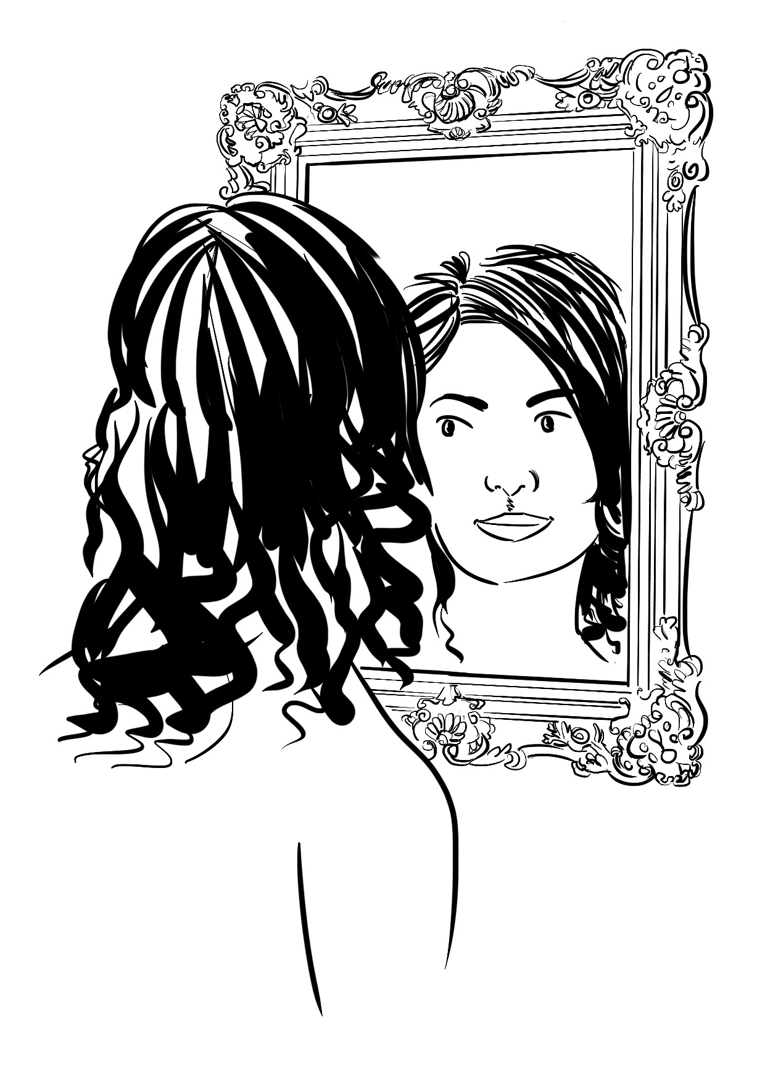

### Background

This model was developed by the wonderfully skilled psychodramatist and action methods practitioner Liz White. In her introduction to her booklet ‘Welcome to Befriending Our Defences’, she outlines the different relationships we have with role states:

* **Role perception:** we see and understand a role from a distance (we can see nurses in hospitals in role, but have no interest in becoming a nurse).
* **Role expectation:** we approach a role but don’t yet take it (for example when preparing to take on a new job)
* **Role taking:** we take on a role but are not yet fully comfortable in it
* **Role playing:** we know how to take this role and can integrate it in our lives.
* Role overdevelopment: we use a role so habitually that it is played too often, and becomes routine and unspontaneous
* **Resistance to balancing roles**: we cling to familiar roles like a lifeline and resist the alternatives with alarm – to trust is to be a fool, to acknowledge vulnerability is to expose yourself, to step back from helping others all the time is to be lazy or selfish.
* **Role relief** – to put an overdeveloped role down and try out a new one. This can make people feel uncomfortable initially as they lost a very familiar comfort zone, but then frees up new energy and possibilities.

This last involves **recognising the price you are paying** for the attachment to an overdeveloped role (exhaustion, loss of sense of self, feeling unseen) and also **recognising our own adverse reaction to the new balancing role**.

Making friends with our resistance in effect allows us to make peace with parts of ourselves which are in conflict and to embrace change.

### How it works:

1. Start with the circle of strengths activity (see p. 26). These strengths give us spontaneity – the chance to see and evaluate what’s needed from a calm and centred place.
2. Place outside the circle four defensive ‘bunkers’ or role states, the places we sometimes retreat to when we feel anxious or threatened:

* **The annihilator** (feelings of power and self-isolation caused by blaming and shaming others and seeing others as ‘the enemy’. Afraid to admit to own feelings of vulnerability, shame and powerlessness).
* **The accommodator** (hyper-vigilant people pleaser, who will do anything to keep the peace and others’ approval. Needs to be liked and often feels invisible. Finds it hard to admit to anger, bearing grudges, not being ‘nice’ inside).
* **The controller** (needs to anticipate and analyse difficulties, find solutions and impose these on others as rules or control mechanisms. Takes lots of responsibility, can’t understand points of view of others who disagree with me. Secretly terrified of chaos and collapse, overwhelmed and unable to ask for help from others).
* **The cave dweller** (disappears, feels cynical and isolated, don’t trust others, can have addictions, feels heavy and oppressed, keeps others guessing or gives them a hard time. Secretly feels very lonely, needs to make connections, talk and share without being patronised or judged).

1. Check with the person you’re supporting which of these places feels familiar as their ‘defensive base-line’ when they are struggling.
2. Use clay or draw a representation of this defence role
3. Write or speak some appreciation of this role – their gratitude for its efforts on their behalf, what aspects of it they wish to keep, what changes they intend to make moving forward as they take on new roles.
4. Share and reflect on the process on completion.

### Before you use this activity

It is important to try this activity for yourself, if possible with peer support, before trying it with others in order to integrate and get inside the learning and model authentic approaches. Also to appreciate just how powerful and potentially challenging this work can be – you need to approach with care and make sure you have good supervision in place if you are working at this level.

## Last word — breakthrough psychology

### Growth mindsets

We support everyone we work with to adopt a **growth mindset.** This means taking an experimental approach, trying new things in order to learn, putting in effort to gain mastery, learning from mistakes and actively seeking feedback, rather than fearing failure and avoiding exposure.

### Mindfulness

In all our work we offer ‘pause points’ to raise awareness, practice noticing and staying fully present in the moment. Research has found that the use of mindfulness can have a direct impact on the brain's 'hard wiring', and that frequent use develops both resilience and clarity of thinking.

### 

### Re-Framing

This powerful change tool invites deeper reflection about beliefs and assumptions relating to self, wider world and future.  We interpret events and situations via the ‘lens’ of our self beliefs: if these are negative, we make negative assumptions and assign meanings which confirm our original self / world view. By questioning the validity of these kind of beliefs and assumptions, and looking for more objective evidence, we can start to change them, which in turn allows for new approaches – hopefully creating a positive upwards spiral change effect.